**Project Plan**

**for**

**Home Automation**

**Emre Özincegedik**

**185050801**

**Contents**

**1. Overview**

**2. Goals and Methods**

**-2.1. Project Goals**

**-2.2. Project Methods**

**-2.2.3. General Problem**

**-2.2.4 Technical Problem**

**3. Software module**

**4. Project Time Management**

**-4.1 Timeline Chart**

**5. SMART criteria**

**-5.1. Specific**

**-5.2. Measurable**

**-5.3. Achievable**

**-5.4. Realistic**

**-5.5. Time Related**

**6. PMI diagram**

**7. Technical-Management Complexity Table**

**1. Overview**

* **This automation has potential to make home life much easier**
* **It is directive to normal user**
* **This automation will be Arduino based**
* **Considering the hardware, software requirement**
* **To release full working project I need 12 weeks**
* **It is aimed for the people who don’t want to micro-manage simple home tasks**
* **Automation will support remote control via phone’s Bluetooth**

**2. Goals and Methods**

**2.1. Project Goals**

* + **Real time response**
  + **Save time, effort and money**
  + **Compact for physical storage**
  + **Phone app for remote control**
  + **Remote, automated and manual lamp control**
  + **Automated watering system**
  + **Timer for power cuts for later analysis**
  + **Output last log to small screen (no storage)**

**Priorities**

**1. Functional goals**

Response time

Dependency

**2. Technological Goals**

Usability

Portability

Improvements

**2.2. Project Methods**

* **Arduino Uno board for micro-controller**
* **Programming languages: C++ language for Arduino and MIT App Inventor for phone app**
* **Libraries for languages will be updated when used as necessity, Arduino Library is included**
* **Possible 3rd party app support for phone app**
* **Hardware specifications: A male to B male USB cable for programming Arduino, Bluetooth module, 5v relays, water pump, water sensor, OLED screen for data output, breadboard, time module**
* **Hardware diversity and numbers may vary along with project**
* **Software specifications: Arduino compatible Integrated Development Environment (IDE), MIT App Inventor, Bluetooth drivers**

**General Problems**

**Fragile equipment**

**Intermediate installation (120 V equipment)**

**Technical Problems**

**Insecure Bluetooth communication**

**No auto-updates**

**3 -Software Module**

Software is heavily focused on the Arduino micro-controller for automation, therefore depends on the C++ language and Arduino library. Arduino board will process the incoming data and act accordingly such as:

* Lights on the house can be automatically toggled to on or off during given times (Prototype will have 2 light switches) also remote control via phone will be available as well as manual control from home wall will be present.
* Automatic watering system for plants will consist of water sensor and water pump. Arduino will automatically open water pump to plants according to the incoming data from water sensor near the plants
* Time module will act as timer and will be responsible for some tasks, mainly for setting a timer for electrical shortages and inform the user for future analysis
* User interface will have 2 parts. First is on the OLED screen which is wired to Arduino directly. Screen will only display the last data and it will be used for information only. Datas on the screen are as follows:
  + Current time of the day
  + Lights’ status
  + Humidity on plant
  + How much time has passed during the last power shortage
* Only the last given data will be displayed on the screen because of storage difficulties
* No interaction will be possible on the OLED screen.
* Second user interface will be on the phone and will be used as a remote control for lights, as well as reviewing the same data on the OLED screen

**4. Project Time Management**

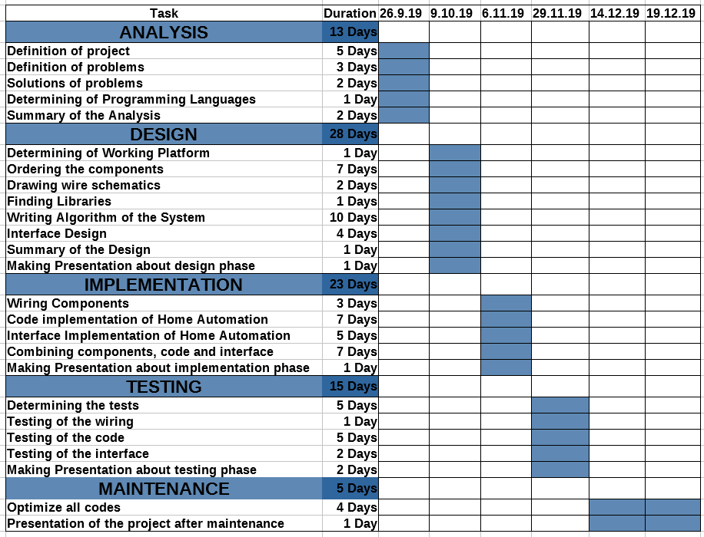

**5-Smart**

* **Specific: develop home automation that allows user to get rid of micro managing simple home tasks**
* **Measurable: It depends exactly on the software programmer’s knowledge and concentration**
* **Achievable: By a time line and wide phase for analysis I can approach my goal**
* **Realistic: Hard constrains and intuitive student to keep track details**
* **Time related: maximum the project will launch before 2 weeks of deadline**

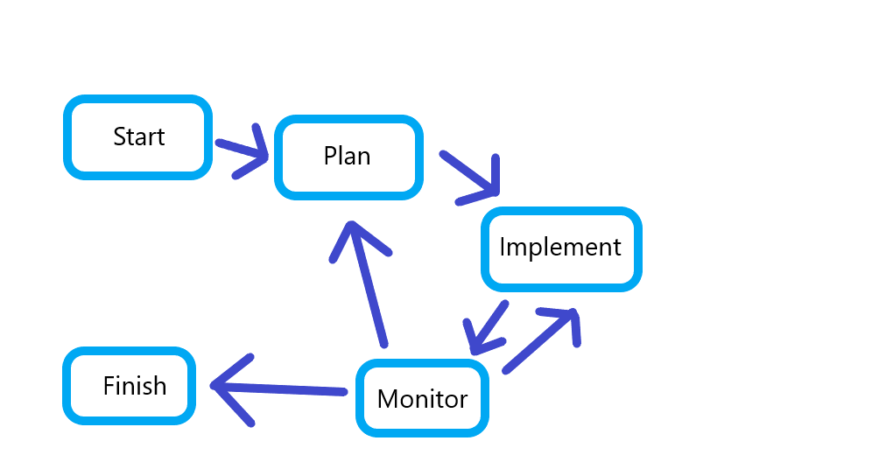**6. PMI Diagram**

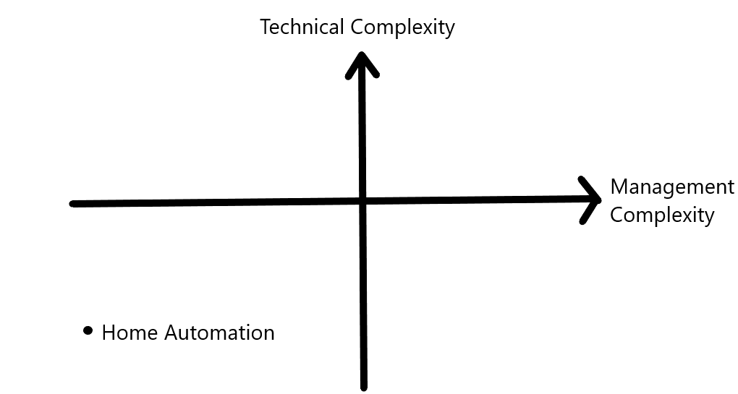

**7. Technical-Management Complexity Table**

**8. Pricing**

**Analysis**

Average work salary3500 TL monthly

Required tools for planning

PC 3500 TL

Mouse 40 TL

Microsoft Office 365 Personal 412 TL

**Design**

Average work salary3500 TL monthly

Gathering components (Arduino 55TL, Water Sensor 3 tl, Timer module 10 TL, OLED Screen 50 TL, breadboard 10 TL, breadboard power supply 10 TL, 5v relays 20 TL, Water pump 70 TL, bluetooth module 30 TL, cables 30 TL, 9v battery 15 tl) (Total: 273 TL), logic design, interface design, drawing schematic, interaction of components table

**Implementation**

Average work salary3500 TL monthly

Coding, combining everything (At least 200 locs + phone app)

**Testing**

Average work salary3500 TL monthly

Handling edge cases for software and hardware

**Maintenance**

Average work salary

Project closing

Couldn’t calculate all due to inexperience, with the current things it’s at least 14,725 TL

**9. Project Sources**

<https://github.com/emreozincegedik/software_enginering_home_automation>